Project Report Resubmission Guidelines

**Table of Contents**

1. Synopsis
2. Preamble  
    2.1 General Introduction  
    2.2 Module Description
3. Review of Literature
4. Technical Description  
    4.1 Hardware Requirement  
    4.2 Software Requirement
5. System Design and Development  
    5.1 Architectural Design  
    5.2 Class Diagram  
     5.2.1 Dynamic Modeling  
      • Use Case Diagram  
      • Sequence Diagram  
      • Activity Diagram  
    5.3 Database Design  
     5.3.1 Relationship Diagram (ER)  
     5.3.2 Menu Design  
     5.3.3 Screen Design
6. Conclusion
7. Learning During Project Work
8. Bibliography  
    8.1 Offline References  
    8.2 Online References

**Table Index**

| **Table No.** | **Title** |
| --- | --- |
| Table 4.1 | Hardware Configuration |
| Table 4.2 | Software Requirements |
| Table 5.1 | Student Record Structure |
| Table 5.2 | Attendance Example Dataset |
| Table 5.3 | Marks Example Dataset |

**Figure Index**

| **Figure No.** | **Title** |
| --- | --- |
| Figure 5.1 | System Architecture Diagram |
| Figure 5.2 | Use Case Diagram |
| Figure 5.3 | Sequence Diagram |
| Figure 5.4 | Activity Diagram |
| Figure 5.5 | ER Diagram |
| Figure 5.6 | Dashboard Screen |
| Figure 5.7 | Results Screen |
| Figure 5.8 | Login Screen |

**Sample Captions (Chapter-wise Numbering)**

**Chapter 4 – Technical Description**

**Table 4.1 Hardware Configuration**

| **Processor** | **RAM** | **Storage** | **Graphics** | **Network** |
| --- | --- | --- | --- | --- |
| Minimum Intel Core i3 | Minimum 4 GB | 120 GB SSD | Integrated graphics | High-speed internet |

**Table 4.2 Software Requirements**  
(Shows OS, Python version, Flask, Browser, etc.)

**Chapter 5 – System Design and Development**

**Figure 5.1 System Architecture Diagram**  
*(Client → Flask → Students.txt)*

**Figure 5.8 Login Screen**  
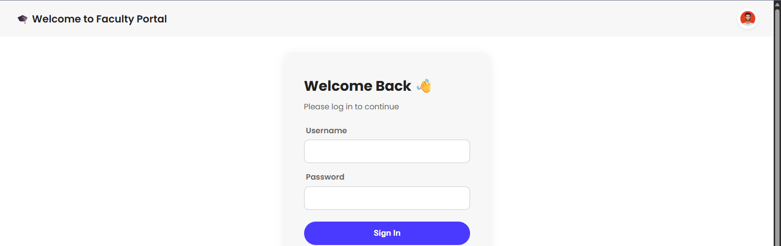

**Chapter 8 – References (in IEEE Format)**

**8.1 Offline References**

[1] A. Silberschatz, H. F. Korth, and S. Sudarshan, *Database System Concepts*, 6th ed. New York, NY, USA: McGraw-Hill, 2019.  
[2] R. Elmasri and S. B. Navathe, *Fundamentals of Database Systems*, 7th ed. Boston, MA, USA: Pearson, 2016.  
[3] M. Grinberg, *Flask Web Development: Developing Web Applications with Python*, 2nd ed. Sebastopol, CA, USA: O’Reilly Media, 2018.

**8.2 Online References**

[4] Flask Documentation, “Flask Web Framework,” [Online]. Available: https://flask.palletsprojects.com. [Accessed: Sep. 8, 2025].  
[5] Mozilla Developer Network, “HTML Reference,” [Online]. Available: https://developer.mozilla.org. [Accessed: Sep. 8, 2025].  
[6] Chart.js Developers, “Chart.js Documentation,” [Online]. Available: https://www.chartjs.org/docs/latest. [Accessed: Sep. 8, 2025].

**✅ Checklist Applied**

✔️ Table Index & Figure Index added  
✔️ Captions for tables & figures added (chapter-wise numbering)  
✔️ IEEE References included (3 offline + 3 online)  
✔️ Certificate page needs to be scanned, inserted after title page in PDF  
✔️ Final PDF must be uploaded to GitHub after guide approval